Preparedness Planning Guide

For Congregations and Parishes
(Comprehensive Version)

From the Director
Dear Episcopal Church Leaders,

Though we don’t always want to think about it, one of our roles as a church in the community is to be prepared to be of assistance after a disaster. We plan for four basic reasons:

- To mitigate the damage to our church community’s buildings and belongings;
- To be able to resume the business of the church as soon as possible post-disaster;
- To support our parishioners in times of crisis;
- To assist to our vulnerable neighbors after an emergency.

The role of Episcopal Relief & Development’s US Disaster Program is to inspire, connect and equip leaders of the US Episcopal Church to prepare for hazards that might affect their communities, as well as mitigate the impact of those disasters and help the vulnerable make a full and sustained recovery.

The “Comprehensive Version” of the Preparedness Planning Guide is designed to help a congregation plan for a disaster, from taking inventory of physical and human assets to determining its niche in assisting vulnerable people in the larger community. This process is best done over several meetings, requiring about 10 to 15 hours to complete. To assist in the process, we’ve created a Facilitator’s Guide that a group leader can use to facilitate a planning team in completing the heart of the plan in four meetings of 60 to 90 minutes. It can be downloaded for free from Episcopal Relief & Development’s Resource Library, www.episcopalrelief.org/resourcelibrary.

We recognize some congregations might not yet be ready for a full disaster planning process. Two abbreviated versions of the guide can also be downloaded from our Resource Library (www.episcopalrelief.org/resourcelibrary.) The “Silver Level” version includes necessary basic information to protect parishioners and church property in times of disaster, and also lays the foundation for congregations interested in responding to their most vulnerable neighbors after a disaster. The “Bronze Level” includes the most basic information needed in times of disaster. An index that cross-references the sections of all three guides can be found at the end of this resource.

Episcopal Relief & Development’s US Disaster Program is working with dioceses around the country to help them be better prepared for emergencies. That includes training and supporting Diocesan Disaster Coordinators, who have been appointed by their bishops. A list of Diocesan Disaster Coordinators can be found on our website at www.episcopalrelief.org/usdisasterprogram. They should be your first support and resource through this planning process.

The Preparedness Planning Guide for Congregations and Parishes comes from the collected wisdom of the Church. To compile this guide, we gathered examples of parish and diocesan disaster preparedness guides from around the country as well as from other denominations. We utilized the most important elements from each, while trying to stay as simple as possible. Please let us know if there’s anything in this guide that you think should be changed, added or eliminated, and feel free to edit according to your local context.

Thanks for all you do in this important work,

Katie Mears
Director, US Disaster Program
Episcopal Relief & Development

Thank-you

This guide is not the creation of Episcopal Relief & Development’s US Disaster Program; it is a compilation of the great work of:

Province IV Disaster Preparedness and Response Commission
The Episcopal Diocese of Arkansas
The Episcopal Diocese of Central Florida
The Episcopal Diocese of Central Pennsylvania
The Episcopal Diocese of Connecticut
The Episcopal Diocese of East Tennessee
The Episcopal Diocese of Florida
The Episcopal Diocese of Kansas
The Episcopal Diocese of Louisiana
The Episcopal Diocese of Rio Grande
The Episcopal Church in South Carolina
The Episcopal Diocese of Southeast Florida
The Episcopal Diocese of Southwestern Virginia
The Episcopal Diocese of Texas
The Episcopal Diocese of West Tennessee
The Episcopal Diocese of West Texas
Lutheran Episcopal Services in Mississippi

This work owes special thanks to:
Karin Hamilton and her committee in the Diocese of Connecticut
and Carolyn Gibbs in the Diocese of Texas

Dave Baylor
Dianne Britton
The Rev. Daniel Harris
Sharon Jones
The Rev. Curtis Metzger
The Rev. Canon E. Mark Stevenson
Carol Stewart
Ryan Velasco
The Rev. Paul Wehner
John D. Webster, Church Insurance Company of Vermont

and

Participants of the Disaster 101 Training in the Diocese of Olympia

© Copyright 2011
Foreword

We know there is a lot going on in the life of a church, and it is easy for disaster preparedness to fall by the wayside. But when something does happen and no preparations have been made, it can be very difficult for that community. Here's one congregation’s story to help illustrate the importance of this work.

St. John’s Firestorm – May 9, 2004
The Rev. Dr. Gail Keeney-Mulligan

It was Sunday afternoon (Mother’s Day) and we had just arrived at St. John’s for a Women’s Bible Study. I walked through the hall, down the stairs and unlocked the lower level office entrance doors for the women to enter. It was 5 p.m. and we sat down in a classroom below the hall to begin our study.
At 5:20, there was a huge “boom!” sound upstairs. I thought that someone had come in and slammed the doors. The next thing we knew there was the smell of smoke. I opened the stairwell door only to find it filled with smoke. There was no back door exit and no way to climb out through the windows. We could, thank God, go out the doors down the hall near the church.
When we got outside we found a large crowd screaming that there were people inside. Fire trucks were arriving. Within minutes the entire upstairs hall and everything in it was gone. We still don’t know what caused the fire, as all the doors were locked and no one was inside except the study group. There were no accelerants found and there were no electrical causes.
It was sobering to realize, later, that the location of the fire and the speed with which it spread could have blocked our getting out of the building, as the stairwell was hot and smoky and was between our classroom and the exit we had to use.
The heat of the fire was so great that it affected the stained glass windows behind the altar and given another ten minutes, would have caused serious damage in the chancel area. The water from the fire fighters soaked computers and file cabinets, destroying many records and much of our important resources and materials. There were no fire alarms and no sprinkler systems in the old building.
Our ongoing ministries were saved by the awesome relationship we have with the interfaith community of New Milford. Even as the firefighters were still exploring the cause of the fire and explosion — and parish members, along with Jack Spaeth and Bishop Curry, sat outside the building in vigil — the priest of St. Francis Xavier Roman Catholic Church arrived and handed me keys to their building at the top of the New Milford Green to use as needed. A short time later, Rabbi Norm Koch gave us keys to his hall and the Congregational Church next door gave us space to save all the records we could salvage as well as rooms for our Sunday School classes and our after school program.
We were very fortunate to have a member of the Congregational Church rent to us a little house he had just bought and was upgrading for rental, which stood between our church and theirs.
When we consider who and what we could have lost, what we did lose, and how it took a village for us to carry on our ministry and mission, it’s humbling. Since the fire, we have made significant changes in our building, our storage, and in safety procedures for the unexpected.
This Outline for Parishes has shown us even more things we can and should do to protect the people, property and records of our life together in Christ.

The Rev. Dr. Gail Keeney-Mulligan
Rector, St. John’s Episcopal Church, New Milford, CT
Member, Bishop and Diocesan Executive Council
Table of Contents
Leadership  Who will take responsibility for preparedness activities? | 9
• Congregational Disaster Coordinator / Disaster Leadership Team | 9
• Disaster Leadership Team – Contact Information | 1011
Goals  What does your congregation want to do in case of disaster? | 12
• Preparedness Goals / Forming Goals | 13
• Congregational Goals | 14
Risk Assessment  What emergencies have happened before and what should you prepare for? | 15
• Local Crisis History | 16
• Brainstorm Possible Disasters and Emergencies | 17
• Identify Groups that Include or Serve Vulnerable People | 18
Property Assets  What do you have that you need to protect? | 20
• Inventories of Property-Related Assets | 21
• Inventory Form | 22
• Items to Protect | 23
• Items to Bring in an Evacuation | 24
• Church "Go Kit" | 25
• Insurance Information | 26
• Secure Storage of Archives and Records | 28
Response & Recovery Capacity  What and whom do you have that will help you respond after an emergency? | 29
• Congregational Resources | 30
• Congregational Activities Resources | 31
• Members with Disaster-Related Skills/Certification/Resources | 33
• Member Questionnaire | 34
• Goals and Response | 37
Communication & Outreach  Whom do you need to contact after an emergency, how and for what purpose? | 38
• Important Contacts | 40
• Diocesan Contact Information | 44
• Church Staff Contact Information | 46
• People with Financial Authorization Approval | 47
• Congregation’s Emergency Contacts | 48
• Local Preparedness and Response Organizations | 49
• Vendor Contact List | 50
• Outside Users of the Building | 51
• Local Media Information | 52
Developing Templates for Initial Response  The first steps you should take in the immediate aftermath of a disaster | 54
• Example: Major Disasters with Warning | 54
• Example: Local Emergencies with No Warning | 55
• Template: Major Disasters with Warning
• Template: Major Disasters with No Warning
• Template: Local Emergencies with Warning
• Template: Local Emergencies with No Warning
Appendix: Table of Contents, All Versions
Compares Comprehensive, Silver and Bronze versions

Our Congregation’s Disaster Plan

- Congregation/Church: | St. Michael’s Episcopal Church
- Phone: | 916 488-3550
- Address: | 2140 Mission Ave.  Carmichael, CA 95608
- Congregational Disaster Coordinator: | Rev Mary Claugus
- Cell Phone: | 925 330-0490
- Landline: | 916.488-3550
- Diocesan Disaster Coordinator: | Margaret Dunning
- Cell Phone: | 707-592-6002
- Landline: | margaret@dunning.com
- Date of Completion:
- Scheduled Review:

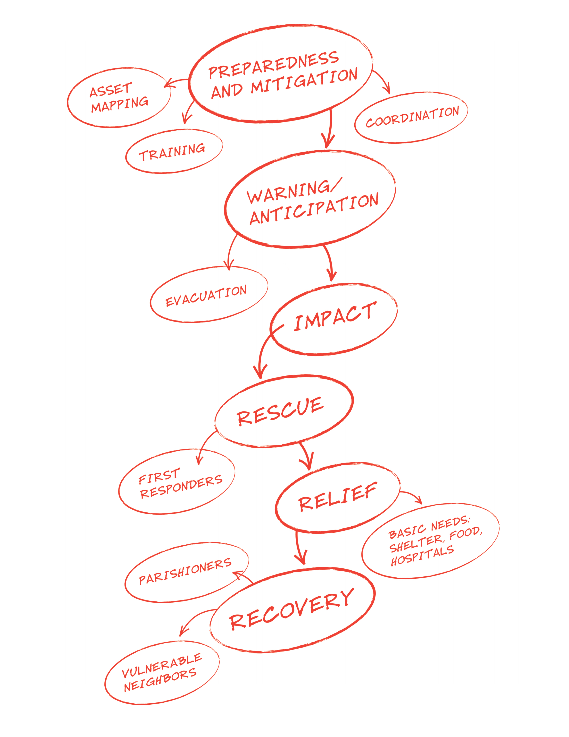

Leadership

Invite interested congregational members to take a leadership role so that you’ll have the necessary direction to plan for and respond to all disasters. The responsibilities of this leadership include: developing the initial disaster response plan, making sure it’s reviewed at least annually, and implementing it when necessary.

As key decision makers, leaders must be familiar with the plan that has been developed and their role in coordinating the response to the disaster. You must ensure that the plan is operational, and that it is well communicated to the congregation and community.

Congregational Disaster Coordinator
The Congregational Disaster Coordinator provides leadership and guidance to the congregation in advance of, during, and following an emergency. This individual should ideally be a regular member of the congregation, familiar with its facilities and families. S/he should be available to enact the emergency plan and oversee the collective activities of the Disaster Leadership Team members; therefore, it is best if this role is not filled by a professional disaster responder who will be unavailable following an event. It is also best that clergy on staff not fill the role of Congregational Disaster Coordinator so that they can meet the spiritual and emotional needs of the congregation and community in times of disaster. However, it is likely that the priest may be able to suggest candidates for this role.

Disaster Leadership Team
The Disaster Leadership Team should include the Congregational Disaster Coordinator, and a group of committed individuals willing to support the Coordinator and the congregation in preparedness and response efforts. This group can be small; in some congregations three might be appropriate, in others as many as eight to ten.

Possible members for a Disaster Leadership Team:
- Rector/vicar/priest-in-charge
- Assisting clergy
- Junior and senior wardens
- Parish administrator
- Altar Guild leader
- Other possibilities: sexton, church school director, parish nurse, parish historian, webmaster, etc.
- People with expertise and/or connections within the disaster/emergency response field
- People with experience in planning
- People willing and able to help in designated areas of responsibility

The responsibilities of the Disaster Leadership Team include:
- Developing, reviewing and knowing the disaster plan
- Leading drills or trainings as needed
- Communicating the plan fully to the congregation and community (through trainings, preparedness Sundays, etc.)
- Helping to resume congregational life as soon as possible after a disaster
- Protecting church assets after a disaster
- Serving the congregation during the acutely stressful time after a disaster
- Mirroring to the community Christ’s commitment to truth, mercy, justice and love

To do this the Disaster Leadership Team must:
- Know their own area of responsibility within the plan
- Review and update the plan regularly to make sure it is operational
- Activate the preparedness or post-disaster plan after a disaster
- Evaluate the plan when enacted; make changes as needed
- At regular intervals, invite new members to join the Team

Disaster Leadership Team:

Contact Information

Instructions: Fill out the following form with contact information for your Congregational Disaster Coordinator and the Disaster Leadership Team. Even if your team consists of two people, capture their contact information.

Congregational Disaster Coordinator:  Mary Claugus | - Landline: | 916 488-3550
 | - Cell Phone: | 925 330-0490
 | - Email: | revmary@stmichaelscarmichael.org
- Name:  - Jan Bowdler | Role/Designated Tasks: | Emergency response
 | Address: | 9340 Crossrail Drive  Wilton, CA 95693
 | Landline: | 916-667-3273
 | Cell Phone: | 916-508-2170
 | Email: | Janbowdler@comcast.net
- Name:  - Suzanne Phinney | Role/Designated Tasks: | Sr. Warden
 | Address: | 2007 Lambeth Way  Carmichael, CA 95608-5756
 | Landline:
 | Cell Phone: | 916-359-0899
 | Email: | Slphinney04@gmail.com
- Name:  - Jim Cole | Role/Designated Tasks: | Buildings and Grounds, Technical Support
 | Address: | 7741 Tobia Way  Fair Oaks, CA 95628
 | Landline: | 916-488-0979
 | Cell Phone: | 916-214-1177
 | Email: | Jcole50@aol.com
- Name:  - Andy Chamness | Role/Designated Tasks: | Sexton
 | Address: | 3611 Cody Way  Sacramento, CA 95864
 | Landline:
 | Cell Phone: | 916-862-3495
 | Email: | andrewchamness@gmail.com

Disaster Leadership Team:

Contact Information, Page 2

- Name:  - Doug Davy | Role/Designated Tasks: | Contractor/Sub Contractor liaison, Church construction plans
 | Address: | 2011 Shelfield Drive  Carmichael, CA 95608-5513
 | Landline: | 916-359-4805
 | Cell Phone: | 916-798-8232
 | Email: | douglasmdavy@gmail.com
- Name:  - Rhonda Grey | Role/Designated Tasks: | Parish Admin
 | Address: | 1351 Gary Way  Carmichael, CA 95608
 | Landline:
 | Cell Phone: | 916-996-8966
 | Email: | rhonda@sstmichaelscarmichael.org
- Name:  - Deacon Cindy  Long | Role/Designated Tasks: | Pastoral Care/protecting the vulnerable
 | Address: | 7041 Verdure Way  Elk Grove, CA 95758
 | Landline:
 | Cell Phone: | 916-261-1341
 | Email: | Deaconcindy@stmichaelscarmichael.org
- Name:  Rev.Mary Claugus | Role/Designated Tasks: | Rector
 | Address: | 629 Laurel Dr.  Sacramento, CA 95864
 | Landline:
 | Cell Phone: | 925-330-0490
 | Email: | revmary@stmichaelscarmichael.org

Disaster Leadership Team:

Contact Information, Page 3

- Name:  - Christina Manning | Role/Designated Tasks: | Liaison with support organizations (i.e., Red Cross, etc.) Training
 | Address: | 1076 Sand Bar Circle  Carmichael, CA 95608
 | Landline:
 | Cell Phone: | 619-508-4423
 | Email: | Chrism812@gmail.com
- Name:  - Kate Muris | Role/Designated Tasks: | Book Keeper and Insurance
 | Address: | 4413 Pasadena Avenue  Sacramento, CA 95821-2920
 | Landline: | 916-487-1936
 | Cell Phone: | 916-201-3546
 | Email: | Katherinemuris@gmail.com
- Name:  - Jim Sargent | Role/Designated Tasks: | Records, electronics, Technical support
 | Address: | 5116 Whisper Oaks Lane  Carmichael, CA 95608-3435
 | Landline:
 | Cell Phone: | 916-761-8880
 | Email: | jim@2sargents.com
- Name:  - Bob McMichael | Role/Designated Tasks: | Treasurer
 | Address: | 2110 Rockwood Drive  Sacramento, CA 95864-1655
 | Landline: | 916-359-3506
 | Cell Phone: | 916-600-5348
 | Email: | bobmcm@surewest.net

Goals

Use this goal section to think broadly about who your congregation wants to be and how those values might be reflected in your disaster response work. Imagine a disaster has hit, and you and your committee are reflecting on what has occurred. What do you want to say about yourselves? – “We did a great job taking care of our elderly members; we were able to smoothly navigate insurance systems; we made an important contribution to the recovery of our poorer neighbors.” This section is a place for this type of broad thinking.

Preparedness Goals

In putting together this guide and talking with church leaders around the country, we have realized that all preparedness, response, recovery and hazard mitigation work can be can be categorized into four goals:

Resuming congregational life as quickly and smoothly as possible

Protecting the church’s assets

Supporting impacted parishioners to recover

Reaching out to vulnerable neighbors

Coordinate with St. Michael’s Day School

If your congregation is prepared, it will be able to achieve these goals more quickly and efficiently after an emergency.

Forming Goals

Broadly think about who your congregation wants to be and how those values might be reflected in your disaster response work. The Disaster Leadership Team should identify the highest priorities specific to your congregation during and after a disaster. Goals should be simple and reflective of the needs and abilities of your congregation and the mission of your diocese, and agreed upon by each member of the team.

Mission Statements

Look at your church and diocesan mission statements, and think about how disaster response can align with this larger purpose. Include those statements here to provide a framework for your goals.

Diocesan Mission Statement: | Making Disciples, Raising Up Saints & Transforming Communities for Christ.
Congregational Mission Statement: | Centered in our love for Jesus, we worship God, reach out to those in need, celebrate our blessings, and love and care for each other. We are inclusive and welcoming of all God's people. Together, we strive to faithfully meet the challenges of a changing world.

Congregational Goals

This is an exercise to think of who you are as a congregation and what you want to accomplish after a disaster. This is a definition of what you will strive to accomplish after a disaster; the specific steps to accomplish these goals will be defined later in the guide.

Examples of goals may include:
- Ensuring the safety of older and disabled members of the congregation
- Providing an effective relief ministry to the local community after a disaster
- Protecting valuable church assets
- Reestablishing Sunday services as soon as possible post-disaster

1) | Reestablishing Sunday services as soon as possible.
2) | Protecting the church’s assets
3) | Supporting impacted parishioners to recover
4) | Reaching out to vulnerable neighbors
5) | Coordinating operations with St. Michael’s Day School

Risk Assessment

Identify any vulnerabilities and hazards to your community so you know what you are preparing for. Take steps to mitigate the impact of those risks on your church, parishioners and neighbors. Know who and what is most vulnerable during all types of emergencies and plan to protect or help them accordingly.

Local Crisis History

Past emergencies can help to predict the future. Create a list of all local disasters and emergencies that have occurred in your parish and in your community in the past 50 years.
A disaster is a non-routine event that causes human suffering or creates human needs that survivors cannot alleviate without spiritual, monetary, material, and/or physical assistance. An emergency is a sudden, generally unexpected occurrence or set of circumstances demanding immediate attention.
In addition to all local and regional natural hazards, be sure to include major economic crises, mass violence, disease outbreaks and other non-weather related emergencies in your list.

Past Disaster/emergency: | Description of effects:
Flood | Two rivers run through Sacramento and neighbors and parishioners live near the river. May need evacuation/shelter
Fire | May need shelter, food, clothing
Law enforcement event | Lock down of area, may require phone contact to check on parishioners
Power outages | During storms, power outages may impact older parishioners who may need medical assistance
Extreme weather | Phone contact may be needed
Chemical-hazardous material event | Evacuation may be needed, food, shelter
High wind | Resulting in downed trees, power outages. May need evacuation.

Brainstorm Likely Disasters and Emergencies

Make a list of all potential disasters/emergencies. Examples of common emergencies may include: weather and fire-related events, vulnerable adults, lost and missing children, medical emergencies, intruders, etc. Also consider even the most extreme possibilities: chemical spill, fire, mass violence, etc.

After you have created the lists, go through and rank the top 5 that you think are most likely. We will return to these in the final section of this guide, “Developing Templates for Initial Response.”

Major Disasters Local Emergencies
- Flood | - Intruder on campus
- Fire | - Fire
- Extreme weather-heat/cold/high wind | - Power outages
- Terrorist attack | - Medical emergencies
- Pandemic | - Extreme weather

Consider whether your top five events in both columns would be the type that occur with some warning, such as a hurricane or spring river flood, or would happen suddenly, such as a chemical spill. Place them in the appropriate box below.

Major Disaster with Warning | Major Disaster with No Warning | Local Emergency With Warning | Local Emergency with No Warning
- Flood |  |  | - Fire
- Fire |  |  | - Intruder
- Extreme weather |  |  | - medical

Identifying Groups that Include or Serve Vulnerable People

People with special needs will be at higher risk during a disaster. Take the time to identify those people within your congregation, and brainstorm what problems they may face and how you could help with those problems as a congregation.

Instructions: List the groups in the parish that are either comprised of or serve people who might be especially vulnerable after a disaster. These might include senior citizens’ groups, groups for new mothers, and religious education programs that include children with special needs. List the contacts for each group, so that they can be contacted after a disaster to help assess needs and facilitate the response. You will also build a list of these individuals on pg. 31.

Group |  | Contact | Types of needs members might have.
 | St. Margaret’s Guild- women’s group meets monthly in restaurant | No designated leader- Deacon Cindy has roster of participants |  | Age related issues, mobility and health constraints, may live alone
 | Daughters of the King- women’s group meets monthly at church | Sue Corbin |  | Age related issues, mobility and health constraints, may live alone
 | ROMEOS- men’s monthly lunch group in restaurant | Michelle Falcy |  | Age related issues, mobility and health constraints, may live alone
 | Men’s Breakfast Group meets monthly for breakfast at church | Jay Glad |  | Age related issues, mobility and health constraints, may live alone
 | Altar Guild | Janice Bowdler |  | Age related issues, mobility and health constraints, may live alone
 | Choir | John Cozza |  | Age related issues, mobility and health constraints, may live alone

Groups That Serve Vulnerable | Contact | Needs served
Pastoral Partners- keep in touch with shut ins by cards and phone calls | Sue Corbin/ Deacon Cindy Long | Pastoral, contact
Caring Hearts-provide occasional meals to vulnerable with health issues, | Tina Ferriot/Deacon Cindy Long | Meals
Community of Hope Pastoral Ministers-connected with people going through health and other pastoral situations who are often also vulnerable. | Deacon Cindy Long/ Tina Ferriot | Pastoral
Eucharistic Visitors-bring communion to people who are homebound | Deacon Cindy Long/Cheryl Hammond | Pastoral

Property Assets

It’s essential to know what assets you have so that you can protect and care for your property in the event of a disaster. Decide how to protect these assets in times of emergency, whether that’s boarding stained glass windows before a major storm or backing up important records at an off-site location.

Inventories of Property-Related Assets

The three first steps to protecting your property are:

1) Identifying what you have
- Use the inventory form on pg. 24 to make a list of your major assets.

2) Recording the details of this property
- Make a written inventory of any property, buildings and building contents (you can use the form on the next page). It should list what you have and provide appraisals when possible.
- For each building that you have, make a note of the location of the main water shut-off valve, heating system/boiler shut-off and the main electrical panel breaker.
- Make a visual record with a camera and/or a handheld video camera: lay out your valuables – vestments, silver, artwork, historical items, etc. Take photos of each or, with a camcorder, pan slowly across each. Continue the visual record by walking through buildings/properties, stopping at specific points for more detail as needed.
- Keep one copy of the written and visual inventories in a protected place at the church, and keep a second copy of each in a remote location or provide them to the diocesan archives. You may have this already if you’ve completed one for insurance purposes; if so, make sure it’s up to date and that the diocesan archives has a copy.

3) Determining what needs to be removed or protected
- Identify what should be protected or removed. This may include protecting the organ, piano, windows, or archives; quake-proofing furniture, etc.
- Use the form on pg. 30 to record what will be protected, by whom, when, where, and how. Buy any supplies needed to protect those objects, and have them readily accessible.
- Draw a simple floor plan of your building/s, showing the location of the organ, piano, paper records, archives, etc. and file it with your local fire department.
- Make sure copies of your insurance information are kept in a safe on site and include a copy of in your “Go Kit” so that any necessary claims can be filed quickly.

General Inventory Information:

Annual Inventory Date:
- List Only (m/d/y) | 2018
- Photos (m/d/y) | 2018
- Video (m/d/y)
Person(s) Responsible for Conducting Annual Inventory:
- Name: | Jim Cole
- Name: | Jim Sargent
- Name:
Locations of Inventory Records:
- On-Site: | This document-parish secretary
- Off-Site:

Inventory Form-see attached sheets

Inventory of Major Assets
Description | No. | Location | Serial Number | Purchase Cost | Current Value

Items to Protect

Make a list of all the items you cannot remove from the building, and specify how you will protect them. Also include who is responsible for this task.

Item | Protection | Person Responsible
Windows | Boarding | Sexton
Historical records | Store in a fire-proof / quake-proof / flood-proof safe | Parish Administrator

Items to Bring in an Evacuation

Sometimes the only way to prevent damage and ensure the continuity of parish operations is to remove items from site. Valuable pieces that should be removed and preserved whenever possible include: computers, other portable electronics, and church heirlooms.

List of Items to Bring in an Evacuation & Person(s) Responsible:

- Item: sacristy to go kit | Person Responsible: Priest
- Item: Icon of Eliz and John the Baptist | Person Responsible: Rev. Mary
- Item: Keeper of the Flame Photo | Person Responsible: Rev. Mary
- Item: church office to go kit | Person Responsible: Rev Mary or Parish administrator
- Item: | Person Responsible:
- Item: | Person Responsible:
- Item: | Person Responsible:
- Item: | Person Responsible:
- Item: | Person Responsible:
- Item: | Person Responsible:

Church “Go Kit”

Prepare and have ready a church “Go Kit,” containing items essential to holding worship: communion silver, a Book of Common Prayer, and a hymnal. Even if the church building is damaged or inaccessible, services may continue with these items. In most cases, a member of the clergy should be responsible for this item, since they will lead services. This kit should also include important insurance information, back-up files and other documents essential to the continuation of church work.

Person Responsible: Rector, Parish Admin, Sexton
- Phone: 916 488-3550
- Email:

Church “Go Kit” Contents
Software and electronic files (back-up)
Communion silver
Book of Common Prayer
Hymnal
Lists of passwords and usernames: computers, software and websites
Insurance information
Lists of important contacts
A complete set of keys to the church
Disaster Binder

Insurance Information

Make a list of all your insurance information and contacts. Be sure to have a copy of this information in a secure place off-site and another copy in your “Go Kit,” if possible.

Note, if your church is insured through Church Insurance Company, you can call 800-223-5707 to report claims immediately.

- Policy Number: | #000009842 Account Number  Policy # CBP 0009583-0 WC56259005740574975
- Policy is with: | Church Insurance Agency, Vermont Workers Compensation through Liberty Mutual Insurance Company
Phone: | Claims: 800.223.5705
Address: | 210 South St., P.O. Box 5000, Bennington, VT 05201
 | Commercial Package through The Church Insurance Company of Vermont Policy
 | VPP0008755-17
- Original Policy is kept: | Finance Office, on top of file cabinet
Address: | 2140 Mission Ave., Carmichael, CA
- Copy of policy is kept offsite:
Address:
- Policy Type:
Total Value: | $162,952,700
- Policy covers: | Blanket buildings and contents  Flood, foreign and domestic terrorism, water backup and overflow, equipment breakdown, fine arts, ordinance or law, commercial liability, pastoral counseling, hired and non-owned auto, personal injury/advertising injury, employee benefits liability, fire legal liability, medical payments, sexual misconduct liability, directors’ and officers’ liability, employment practices liability, accident medical expense, Crime insurance clauses, commercial umbrella. Buildings: Church/columbarium, Multipurpose bldg., north classrooms, learning resource Center, Classrooms/Admin offices, classrooms/math lab, classrooms/science lab, gymnasium, Theater and Classrooms,
- Other policies:
- Policy review:
When: | July, 2018
By who: | Treasurer and Rector

Be sure to note where off-site copies are kept and who can access them.

Off-site Copies
- Where: | 629 Laurel Drive Sacramento, CA 95864
- Who: | Mary Claugus home office
Phone:
Cell: | 925-330-0490

Secure Storage of Archives and Records (print and electronic)

Appropriate protection of records is essential. If your paper files are charred or water-damaged, or your computer files are lost, you may need to hire professional recovery companies in addition to rebuilding the data. Archival items by nature are irreplaceable.

Refer to the “Records Manual for Congregations” published by the Archives of the Episcopal Church for a list of records to retain and the time to retain them. You can also find this information at: http://www.episcopalarchives.org/Records_Manual_for_Congregations.pdf

- Every congregation needs a fireproof, waterproof, quake-proof lockable box or safe (or safety deposit box). Seldom-used/historical items, valuables and the following should be kept in the safe:
- Parish registers and service books – at all times when not in use
- Confidential records: personnel files, documents displaying social security numbers, and confidential counseling records.
- Contracts, mortgage or loan papers, titles and deeds, other legal documents, etc.
- Routine back-ups for computer files on a CD, DVD or USB
- Paper records and files
- These could include your administrative, financial and ministry files, and copies of print newsletters or bulletins. Store them in metal file cabinets, preferably not on opposite walls from windows. Photocopy irreplaceable files to store offsite.
- Archives
- These are best stored in temperatures between 65-68 degrees, with 45% humidity, in metal cabinetry or shelved in acid-free boxes, in a closed room with no windows. If the room is fireproofed, even better. After fire, water and mildew are the worst enemies.
- Inventory your archives carefully and keep a copy offsite.
- Software and electronic files
- Keep anti-virus and spyware protection up to date, establish protocols for office computer use including password protection, and use a surge protector
- Back-up your office files regularly and keep back-ups in your safe or another secure location off-site. Place a copy in the “Go Kit.”
- Keep your original software CDs in the safe.
- Make backups of your website. Make sure your web-hosting provider regularly backs up their servers and protects the data. Consider a web-hosting service with multiple servers in various locations nationally.
- Keep lists of passwords and usernames for all computers in the church safe/safety deposit box/off-site. Make sure passwords are kept in at least 2 places, and there is a copy in your “Go Kit.” This will help to ensure access to them after a disaster
- Diocesan archive storage
- Provide copies of your architectural drawings and asset inventories to the diocesan archives.

Response & Recovery Capacity

Brainstorm who and what resources you can tap into to help both your parishioners and the members of your greater community recover and work toward creating a “new normal.” Make any necessary plans or preparations for responding to your parishioners – such as communication plans.

Congregational Resources

Identify what facilities or resources your congregation can offer fellow parishioners or to the broader community in the event of an emergency – do you have vehicles? Do you have a space that could be used as a shelter? Do you have a commercial kitchen?

Congregational Property Resources for Use Post-Disaster

Instructions: Make a list of property assets that can be used for response activities in case of an emergency.

List your buildings – include approximate capacity and accessibility
Building | Description
- Church
- Parish Hall and Kitchen | Attached to administrative
- Administrative | Offices and three classrooms

Do you have?
Yes/No | Facility | Description/Quantity
no | - Storage Capacity
yes | - Kitchen Capacity
yes | - Refrigerator/Freezer
yes | - Space to Shelter
yes | - Exterior Grounds
 | - Other:

Are you certified?
Yes/No | Certification
no | - American Red Cross Disaster Feeding
no | - American Red Cross Mass Care
no | - American Red Cross Shelter Care
 | - Other:

What equipment/resources do you have to offer the wider community?
Yes/No | Equipment/Resources | Description/Quantity
no | - Vehicles
no | - Aircraft
no | - Boat
no | - Bus
no | - Generator
no | - Bed/Cot
no | - Tent
 | - Other:

Congregational Activities Resources

Make a list of important activities and services already provided by the congregation. What do you know how to do? What outreach programs does your congregation already run? What vulnerable communities might be associated with those programs? Because you already have the experience and infrastructure in place, these programs may be a good starting point for providing services to the greater community after a disaster.

Activities:
River City Food Bank at St. Matthew’s, Contact Amanda McCarthy
2123 36th Street
Sacramento, CA 95817
916-329-2375
amandamcc@gmail.com
amccarthy@rivercityfoodbank.org

Congregational Human Resource Assets
Primary Languages:
English, several Spanish speakers
Groups that could be of service:
- Active Community Ministries Organization- Arden Arcade Carmichael Faith Community- | Contact Person: Mary Groesbeck/Deacon Cindy
 | Email: maryg32@sbcglobal.net
 | Phone: 916.849.8275
 | Resources they can provide:
 | Skills they can provide:
- Bible Study Group | Contact Person: Rev Mary/Kate Muris
 | Email: revmary@stmichaelscarmichael.org
 | Phone: 925-330-0490
 | Resources they can provide: meals, rides
 | Skills they can provide: pastoral
- Boy Scouts | Contact Person: Harriette and Jack Carr
 | Email: jackcarr@surewest.net
 | Phone: 916.833.7004, 916. 483.8225
 | Resources they can provide:
 | Skills they can provide:
- Choir | Contact Person: John Cozza
 | Email: cozzafamily@aol.com
 | Phone: 916.944.1322, 916.835.5735
 | Resources they can provide: rides, meals, etc
 | Skills they can provide:
- Daughters of the King | Contact Person: Sue Corbin
 | Email: kecorbin@sbcglobal.net
 | Phone: (916) 944-2203
 | Resources they can provide:
 | Skills they can provide:
- EFM Contact | Contact Person: Sue Gaston/Janice Bowdler  janbowdler@comcast.net916.508.2170 jgaston@surewest.net (916) 212-6733
- Men’s Group | Contact: Michelle Falcy – Parish Administrator  St.michaels@stmichaelscarmichael.org  916 488-3550  Food prep for large group, possible basic repairs and shelter construction
- Sunday School | Mary Groesbeck Email: maryg32@sbcglobal.net
- Mercy and Social Justice | Phone: 916.849.8275
- Community of Hope Lay Ministers | Deacon Cindy Long  Email: deaconcindy@stmichaelscarmichael.org  916 261-1341  Pastoral support, home visits  Trained in pastoral care

Members with Disaster-Related Skills/Certifications/Resources

Determine what disaster response skills, certifications or resources parishioners have to offer the parish and wider community. Are there certified chaplains, doctors or nurses?

Instructions: A suggested questionnaire follows on the next page. Include it in your newsletter or Sunday bulletin, and ask that it be returned to the church office or Disaster Leadership Team. You can keep the information current by reprinting the questionnaire annually.

You also could use an online survey (via Survey Monkey or Google forms) to collect and organize this information.

Compile the results in a list that includes the parishioner’s name, contact information, skills and special needs.

Additionally, encourage anyone interested in volunteering after a disaster to sign up for Ready to Serve on Episcopal Relief & Development’s US Disaster Program website:
www.episcopalrelief.org/USDisaster.

Member Questionnaire
Instructions: This questionnaire will help the St. Michael’s Episcopal Church Disaster Leadership Team determine members’ special skills in responding to a disaster, as well as needs that might make them vulnerable in a disaster. Information will be kept confidential, and will only be used by the Disaster Leadership Team to involve parishioners appropriately in disaster response. This was completed. Deacon Cindy Long is the contact for the information.

Basic Information
- Date:
- Name:
- Address:
- Phones: | Home:
 | Office:
 | Cell:
- Email:
Partner/Spouse/Care-giver:
- Phone:
Names and ages of additional household members:
Emergency contact: (not living with you)
- Phone:
- Address:

Special skills I would volunteer (note: any volunteer contact with youth requires Safe Church training):
Yes/No | Skill | For Parish | For Wider Community
 | - Language(s) please list: | Y / N | Y / N
 | - Evacuation | Y / N | Y / N
 | - Clean-up | Y / N | Y / N
 | - Emergency babysitting at home  (how many children): | Y / N | Y / N
 | - Emergency babysitting at church/shelter  (how many children): | Y / N | Y / N
 | - Transportation to doctor (how many people): | Y / N | Y / N
 | - Provide vehicle for evacuation or clean-up | Y / N | Y / N
 | - Provide boat for evacuation or clean-up | Y / N | Y / N
 | - Provide aircraft for evacuation or clean-up | Y / N | Y / N
 | - Provide portable generator | Y / N | Y / N
 | - Temporary housing (how many people): | Y / N | Y / N
 | - Provide non-perishable food | Y / N | Y / N
 | - Provide bottled water | Y / N | Y / N
 | - Provide hot meals or a covered dish | Y / N | Y / N
 | - Cook/serve meals | Y / N | Y / N
 | - Will pray with/for victims | Y / N | Y / N
 | - Have first aid/CPR certification | Y / N | Y / N
 | - Blood donation | Y / N | Y / N
 | - Other: | Y / N | Y / N

Professional Services:
Yes/No | Professional Service | For Parish | For Wider Community
 | - Medical assistance (nurse, MD, EMT, etc.) | Y / N | Y / N
 | - Legal assistance | Y / N | Y / N
 | - Counseling assistance (LSW, LPC, etc.) | Y / N | Y / N
 | - Certified Chaplain | Y / N | Y / N
 | - Ham radio operator | Y / N | Y / N
 | - Professional rebuilding assistance | Y / N | Y / N
 | - Professional tree services and removal | Y / N | Y / N
 | - Other: | Y / N | Y / N

Other Skills or Resources:
Yes/No | Skills/Resources | Description/Date | Willing to work outside parish?
 | - Other disaster training  (CERT, ARC, UMCARE) |  | Y / N
 | - Case management |  | Y / N
 | - Other:  (project development, tools available – list, other services, etc.) |  | Y / N

Special Needs
Does anyone in your household speak only a language other than English?  - Language: | Y / N
Medical Disability:
(Are you: blind / deaf / etc.)
Special medical needs: (i.e., severe cardiac, diabetic on insulin, etc.)
Do you rely on electricity for home medical treatments? | Y / N
Are you homebound?  Do you use a wheelchair?  Do you use a walker/cane? | Y / N  Always / Most of the time / Sometimes  Always / Most of the time / Sometimes
Do you require a special diet?  Type: | Y / N
Do you have pets?  - What kind?  - How many? | Y / N
Do you have transportation in an emergency?  If yes, what type? (i.e.—standard vehicle / wheelchair access / ambulance) | Y / N / Maybe
Is there anything else we should know?

Have you signed up for “Ready to Serve” with Episcopal Relief & Development’s U.S. Disaster Program? Y / N

Return this form to:

Goals and Response

This is a good moment to revisit the goals defined on pg. 15 and identify the necessary steps and resources to ensure that those goals are met. This is the moment to decide what activities are needed to accomplish those goals, what preparation is needed before a disaster, who shall lead each activity and what is needed to do so.

Goal | Preparation | Person Responsible | Activities Post-Disaster
Reestablish Sunday services as soon as possible after a disaster | - Put together “Go Kit”  - Establish relationship with St. Mark’s Church or Faith Episcopal – ask if they will offer space for alternate worship site  - Inform congregation: in case church is affected by emergency, services will be held at alternate site | Rev. Mary or Senior Warden | - Communicate with St. Mark’s  - Inform parishioners via email, phone and note at our parish that services will be held at alternate site  - Provide priest with the implements for service from the “Go Kit”
Check on vulnerable parishioners | Use surveys and directory to identify those to be called | Deacon Cindy and pastoral care team | Use phone tree to contact parishioners

Communication & Outreach

Maintain an updated contact list for the members of your congregation, and specifically include those who are vulnerable so that your team knows to check on their situation, etc. Keep in mind that, depending on the type of disaster, communication may be difficult and you may need various means of communication to reach everyone.

Also, know whom to contact for help and how to plug into a local emergency response network. Make sure to connect with local disaster relief organizations, local government agencies and your local Voluntary Organizations Active in Disaster (VOAD) chapter before a disaster.

Important Contacts

It might be a good idea to have a “bouquet” of contact options available in times of emergency. Because various types of communication may be affected, it’s good to have multiple options.

1) Diocesan, church and congregational emergency contacts
- Contact information for the Diocesan Disaster Coordinator, the Bishop and other important staff at the diocese – use the form on pg. 42.
- Contact information for the clergy and staff – see the form on pg. 43.
- Contact information for partner congregations – see the form on pg. 44.

2) Parishioners
- Create and maintain a list of cell phone numbers and emails of all the members of the congregation if possible – this is a means to communicate, know the status of members and the status of their homes after a disaster. This can be done via mass emails, web pages, Facebook, etc. You may also consider creating a phone tree (see Appendix A). Many times congregations already have that information; try to find out who has that information and where it is, so the disaster team can access it.
- Especially in hurricane-prone areas, have members file their evacuation plans with the church. This allows the congregation (as best it can) to know who left and who stayed, and to have the means to communicate with all members.

3) Parishioners who are infirm, elderly, disabled, or have special needs
Create and maintain a list of people who need to be contacted in a disaster or emergency to see if they need help or special resources. A congregational list can be annotated to note: who is homebound, deaf, disabled, autistic, blind, oxygen-dependent, etc. You can use information gathered with the survey (pgs 35-37) to create this list.

For this list I have gone through the printed roster and highlighted people with particular special needs. I started working on making a group in Realm which could be updated and printed as needed but need to know more about how we want to do this so efforts are not duplicated. Will we have a complete list of entire congregation with any special needs noted or just a list of vulnerable people- which can change pretty frequently. Should be simple to complete once I have some direction on this. Thanks , Cindy

4) Local emergency contacts
- 911 is still the first call to make. They will contact local emergency services, and (depending on the event) coordinate with emergency networks in cities, towns, regions, states and nation-wide.
- Have one local emergency contact and another emergency contact outside your region. Many times these contacts can be partner churches – you can use preexisting relationships you have built both within and outside your diocese. Fill out the form on pg. 44 with their information.
- Have a list with contact information for, and develop working relationships with, your local emergency services and disaster response networks (Red Cross and your local VOAD group – Voluntary Organizations Active in Disasters – etc.). You can ask your Diocesan Disaster Coordinator to help you fill out the form on pg. 45.

5) Insurance company
- If your building is damaged, you will need your insurance agent’s information, as well as policy numbers. Refer to the information you included on pg. 28.

6) Contractors and vendors
- List the contractors you trust like electricians, plumbers, etc. – use the form on pg. 46.

7) Outside users of the building
- See the form on pg. 47.

8) Local print, radio, and broadcast media
- See the form on pg. 48

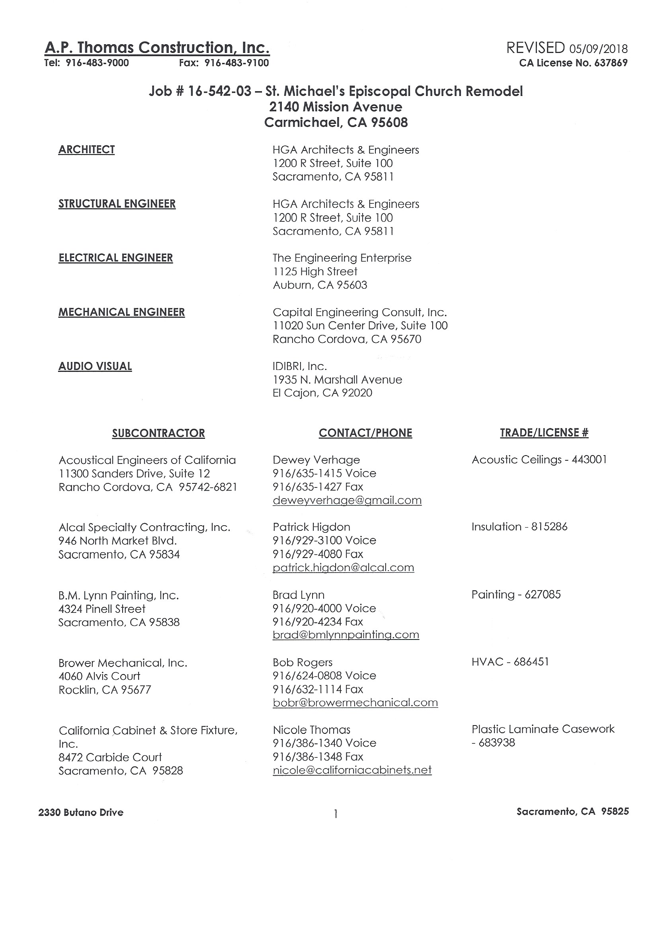

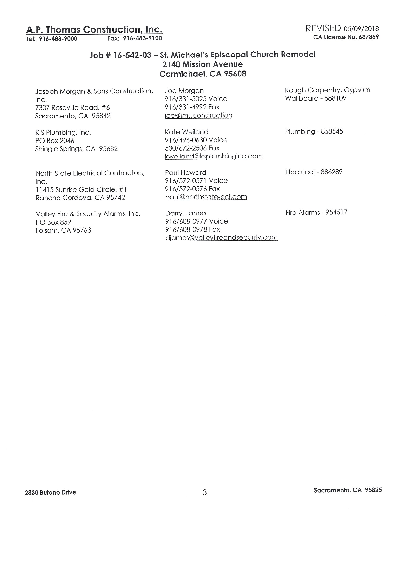
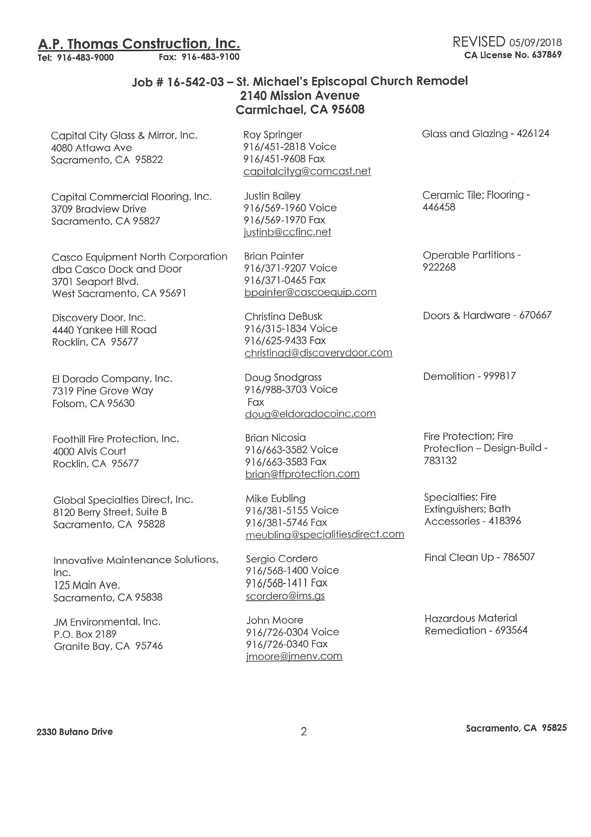
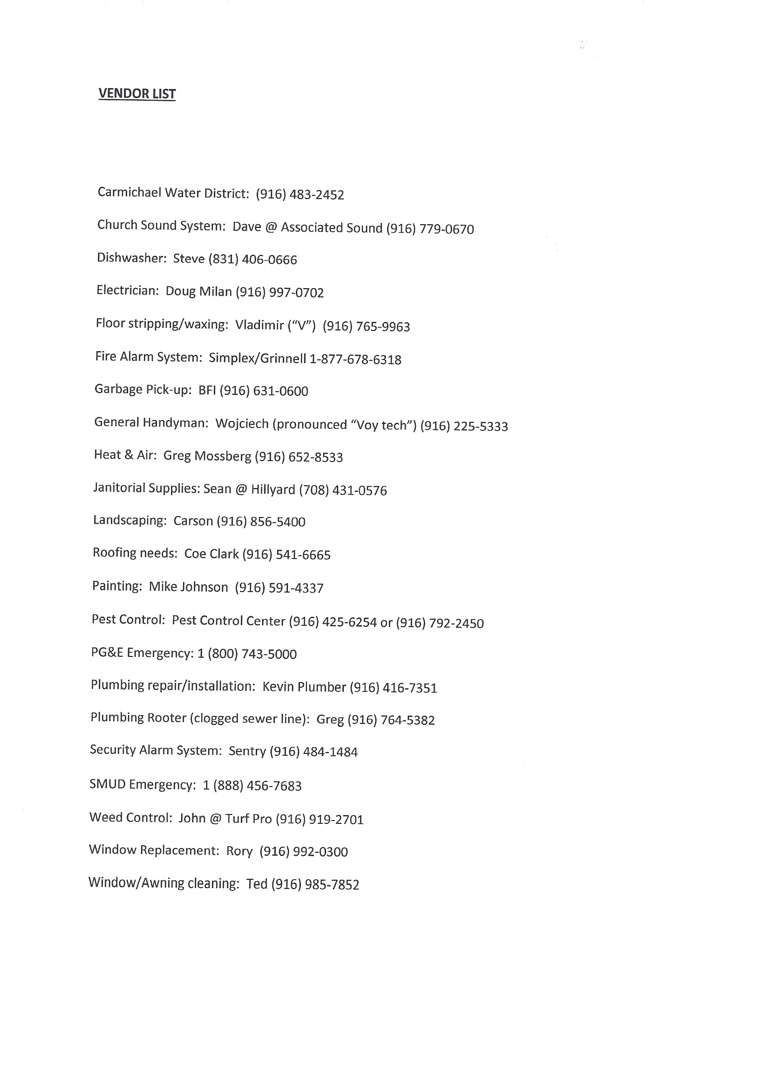
Diocesan Contact Information

Instructions: Change, remove and add titles as relevant to your diocese.
- Bishop  Name: Megan Traquair | Address: | 350 University Ave. Ste. 280, Sacramento
 | Office Phone: | 916-442-6918 x 213
 | Cell Phone: | 916-500-1067
 | Home Phone:
 | Email: | bishopmegan@norcalepiscopal.org
- Canon for Stewardship/Administration  Name: Andrea McMillin | Address: | 350 University Ave. Ste. 280, Sacramento
 | Office Phone: | 916-442-6918 x 214
 | Cell Phone: | 530-601-3774
 | Home Phone:
 | Email: | andrea@norcalepiscopal.org
- Assistant to the Bishop  Name: Jacqi Seppi | Address: | 350 University Ave. Ste. 280, Sacramento
 | Office Phone: | 916-442-6918 x 213
 | Cell Phone:
 | Home Phone:
 | Email: | jacqi@norcalepiscopal.org
- Assistant to the Canon  Name: Kati Braak | Address: | 350 University Ave. Ste. 280, Sacramento
 | Office Phone: | 916-442-6918 x 228
 | Cell Phone:
 | Home Phone:
 | Email: | Kati@norcalepiscopal.org
- Diocesan Disaster Coordinator  Name: Margaret Dunning | Address:
 | Office Phone:
 | Cell Phone:
 | Home Phone:
 | Email: | Margaret@dunning.com
- Communications Director  Name: Lori Richardson | Address: | 350 University Ave. Ste. 280, Sacramento
 | Office Phone: | 916-442-6918 x 226
 | Cell Phone: | 434-964-7948
 | Home Phone:
 | Email: | lori@norcalepiscopal.org
- Chair of Standing Committee  Name: Cookie Clark | Address: | 300 West Street  Vacaville, CA 95688
 | Office Phone:
 | Cell Phone: | 707-488-2275
 | Home Phone:
 | Email: | Cookie.clark@sbcglobal.net

- St. Michael’s Episcopal Day School  Name: Mary Heise | Address:
 | Office Phone: | 916-485-3418
 | Cell Phone: | 916-764-8269
 | Home Phone:
 | Email: | maryheise@smeds.com
- Utonomy - Financial  Name: Brenda Paredes | Address: | 1220 Cerro Vista Drive , P.O. Box 473, Applegate, CA 95703
 | Office Phone: | 916-459-0833
 | Cell Phone: | 916-803-5192
 | Home Phone:
 | Email: | bparedes@utonomy.com
- Arch Deacon  Name: Gary Brown | Address: | 235 S.Church St.  Grass Valley, CA 95945
 | Office Phone:
 | Cell Phone: | 530-273-7876
 | Home Phone:
 | Email: | Garybrown6@yahoo.com
- Arch Deacon  Name: Pam Gossard | Address: | 625 15th St., Eureka, CA
 | Office Phone:
 | Cell Phone: | 707-442-1797
 | Home Phone:
 | Email: | P2gossard@gmail.com
- Chancellor  Name: Charles Mack | Address: | 512 Greenwood Dr., Woodland, Ca
 | Office Phone:
 | Cell Phone: | 530-662-9637
 | Home Phone:
 | Email: | Chasrmack@aol.com

Church Staff Contact Information

Instructions: Make this contact information available to your parishioners.
- Role/Job Title: Rector  Name: Mary Claugus | Address: | 629 Laurel Dr., Sac, 95864
 | Home Phone:
 | Cell Phone: | 925.330.0490
 | Email: | revmary@stmichaelscarmichael.org
 | Emergency Contact:  - Relationship:  - Phone: | Savannah Olivier  Daughter  925.528.9643
- Role/Job Title: Deacon For Pastor Care and Outreach  Name: Cindy Long | Address: | 7041 Verdure Way, Elk Grove, CA 95758
 | Home Phone:
 | Cell Phone: | 916.261.1341
 | Email: | deaconcindy@stmichaelscarmichael.org
 | Emergency Contact:  - Relationship:  - Phone: | Mark Long, Husband  916.202.7264
- Role/Job Title: Assisting Priest  Name: Rod Davis | Address: | 1821 Parliament Circle, Carmichael, CA 95608
 | Home Phone: | (916) 359-7691
 | Cell Phone: | 916.214.3861
 | Email: | fatherrod@stmichaelscarmichael.org
 | Emergency Contact:  - Relationship:  - Phone: | Sue Davis, wife  (916) 359-7691
- Role/Job Title: Sexton  Name:  Andy Chamness | Address: | 3611 Cody Way Sacramento, CA 95864
 | Home Phone:
 | Cell Phone: | 916-862-3495
 | Email: | andrewchamness@gmail.com
 | Emergency Contact:  - Relationship:  - Phone: | Chris Chamness  Brother  916-709-5483

- Role/Job Title: Admin  Name: Mary Ellen Ferguson | Address: | 2709 Butano Drive  Sacramento, CA 95821-6402
 | Home Phone:
 | Cell Phone: | 916.224.3515
 | Email: | Mferguson419@sbcglobal.net
Emergency Contact:
- Relationship:
- Phone:
- Role/Job Title:  - Book Keeper  Name: Kate Muris | Address: | 4413 Pasadena Ave, Sacramento, CA 95821
 | Home Phone: | (916) 487-1936
 | Cell Phone: | 916.929.9162
 | Email: | Katherinemuris@gmail.com
 | Emergency Contact:  - Relationship:  - Phone: | David Muris, Husbank, 916.487.1936
Role/Job title: Chaplain for the School  Name: Lynell Walker | Address:  Home Phone:  Cell Phone:  Email:  Emergency Contact: | 916.804.1614  Lwalker259@gmail.com  Pat, Wife

People with Financial Authorization Approval
Instructions: Keep a copy of this information in your “Go Kit” (pg. 30).
Bob McMichael, Treasurer | Phone: | 916.500.5348
 | Email: | Bobmcm@surewest.net
 | Address: | 2110 Rockwood Dr., Sacramento, CA 95817
Renee Pierce, Sr. Warden | Phone: | 916-539-6495
 | Email: | Renee.pierce99@gmail.com
 | Address:
Mary Claugus, Rector | Phone: | 925.330.0490
 | Email: | revmary@stmichaelscarmichael.org
 | Address: | 629 Laurel Dr., Sacramento, 95864
Emily Brown, Clerk | Phone: | 916.217.3669
 | Email: | emilycolebrown@gmail.com
 | Address: | 7741 Tobia Way, Fair Oaks, Ca 95628
Dave Decker, Jr. Warden | Phone: | 916.834.2818
 | Email: | Decman5150@gmail.com
 | Address: | 2859 58th St., Sacramento, CA 95817

Congregation’s Emergency Contacts

Partner congregations can serve as a center for communications, an evacuation site, or a source of relief volunteers, among other things. Partnering with another congregation within the diocese provides an opportunity to both serve others and receive services in an emergency. A relationship with a congregation located in a separate region not susceptible to the same emergencies at the same time as your congregation should also be established as a possible evacuation site.

It may also be a good idea to keep a complete set of keys to the church at one of these locations, or at your diocesan offices – in case yours are lost.

Partner Congregation – Local
Partner Congregation: | St. John’s Roseville
Contact Person | Cliff Haggenjos
- Landline: | 916-786-6911
- Cell Phone: | 707-235-9728
Address: | 2351 Pleasant Grove Blvd.  Roseville, CA 95747

Partner Congregation – Outside the Diocese

Partner Congregation: | St. Stephen’s, Orinda, CA
Contact Person | Brenda Free
- Landline: | 925-254-3770
- Cell Phone: | 925-899-1244
Address: | 66 St. Stephen’s Drive  Orinda, CA 94563

Local Preparedness and Response Organizations

It is best to develop relationships with other disaster response organizations in your area in advance of an emergency – such as your local Volunteer Organizations Active in Disaster (VOAD) or county emergency management office. They will be key partners in exchanging information, and open lines of communication will be essential to make sure your congregation’s efforts are coordinated with the activities of other organizations. Make a list of these organizations and the people you have contacted within them, and make sure you maintain contact with them regularly.

Community Disaster Organizations & Key Information Sources
- Organization/Person:  Contact Information: | - Contact Name | VOAD, Valerie Mihanovich,  Sacramento Region VOAD Coordinator
 | - Phone | 916 447-7063 Ext 101
 | - Email | vmihanovich@handsonsacto.org
- Organization/Person:  Contact Information: | - Contact Name | American Red Cross, Patricia Davis, Disaster Program Manager
 | - Phone | 916 993-7049, cell 916 597-5232
 | - Email | Patricia.Davis3@redcross.org
- Organization/Person:  Contact Information: | - Contact Name | Margaret Dunning, Community Resilience and Diocesan Disaster Coordinator
 | - Phone | 707 592-6002
 | - Email | Margaret@dunning.com
- Organization/Person:  Contact Information: | - Contact Name | River City Food Bank, Eileen Thomas, Executive Director
 | - Phone | 916 834-6360
 | - Email | ethomas@rivercityfoodbank.org
- Organization/Person:  Contact Information: | - Contact Name | 211 Sacramento
 | - Phone | 211 or 916 498-1000
 | - Email | info@211sacramento.org

Vendor Contact List for Goods and Services

Business | Service | Contact | Phone | Email | Address | City | State | Zip
 | General Contractor | A.P. Thomas | 916 483-9000 |  | 2330 Butano | Sacramento | CA | 95825
Acct.8155600396922778 | Phones | Comcast/  X-finity | 1-800-9346484 | Xfinity.com/customersupport | PO Box 34744 | Seattle | WA | 98124-1744
 | Computer Maintenance | Jim Sargent | 916 761-8880 | jim@2sargents.com | 5116 Whisper Oaks Lane | Carmichael | CA | 95608
 | Elevator Maintenance
 | Generator Rental
 | Electrical Contractor
 | Plumber
 | Glass/Window Repair
 | Snow/Ice Removal
 | Emergency Board-Up
 | Window Cleaning
 | Environmental Hauling
 | HVAC Contractor

Outside Users of the Building

Group | Contact | Phone | Email | Building Use
Centering Prayer | Bev Reed | 916.740.5416 | Zot1982@yahoo.com | Centering Prayer on Wednesday nights, 6:30 – 8:30pm, Church space
Cub Scouts | Mike Tate | 916.284.1445 | mtate@tateadvisers.com | Cub Scouts, Mondays
Boy Scouts | Heath Charamuga | 916-563-3094 | Heath.charamuga@colliers.com | Boy Scouts,

Local Media Information

Type  Print/Radio/  Broadcast |  | Company | Contact | Phone | Email | Address | City | State | Zip
Print |  | Sac Bee |  | 916 321-1000 | Sacbee.com | 2100 Q Street | Sacramento | CA | 995816
Print |  | Carmichael Times |  | 916 773-1111 | Publisher@mpg8.com | 7144 Fair Oaks Blvd | Carmichael | CA | 95608
Print | Folsom Telegraph |  |  |  | Folsomtelegraph.com
Print | Roseville Press Tribune |  |  |  | Thepresstribune.com
Radio | News Radio KFBK |  |  | 916 929-5325 | Facebook Message | 1545 River Park Dr.  Ste. 500 | Sacramento | CA | 95815
Radio | Capital Radio |  |  | 916 278-8900 | Capradio.org | 7055 Folsom Blvd. | Sacramento | CA | 95826
Broadcast | NBC/KCRA 3 |  |  | 916 444-7316 | newstip@KCRA.com | 3 Television Circle | Sacramento | CA | 95814
Broadcast | CBS/KOVR 13 |  |  | 916 3741301 | news@kovr.com | 2713 KOVR Drive | West Sacramento | CA | 95605
Broadcast | Fox/KTXL 40 |  |  | 916 454-4422 | news@Fox40.com | 4655 Fruitridge Rd | Sacramento | CA | 95820
Broadcast | ABC/KXTV 10 |  |  | 916 441-2345 | desk@abc10.com | 400 Broadway | Sacramento | CA | 95818

Developing Templates
For Initial Response

Now that you’ve determined your congregation’s capacity to respond to and recover from potential disasters and emergencies, you’re ready to apply this information to specific types of events. In most cases, the initial response to particular types of disasters will be very similar.

In this section, you will create templates for responding to four general types of crises:

- Major disasters with warning;
- Major disasters with no warning;
- Local emergencies with warning;
- Local emergencies with no warning.

To complete these templates, use the list generated on pg. 19, “Brainstorm Likely Disasters and Emergencies,” to help shape responses that reflect the disasters and emergencies particular to your region. A few examples are included to use as a general guide.

Your initial responses are really only the beginning of disaster response. They will get you through the first hours of a crisis until your Parish Disaster Leadership Committee can meet to determine further actions as the situation unfolds.
For more information on disasters and disaster planning please refer to Episcopal Relief & Development’s US Disaster
Program website at: www.episcopalrelief.org/USDisaster

Initial Response for
Major Disasters with Warning

Description: This plan would work for anticipated disasters such as a major hurricane, where there is time to arrange for an evacuation and protect property before the disaster occurs.

First 9 steps:
 | Step | Time Frame | Person Responsible
1 | Priest calls sexton to protect property | Within 2 hours of evacuation notice | Rector
2 | Call Disaster Leadership Team to activate phone tree | Within 2 hours of evacuation notice | Rector
3 | Call Diocesan Disaster Coordinator to inform diocese of evacuation Margaret Dunning | Within 3 hours of evacuation notice | Congregational Disaster Coordinator, Rev. Mary
4 | Protect windows and doors, cover organ & unplug electronics | Within 5 hours of evacuation notice | Sexton and Buildings and Grounds
5 | Walk through church to make sure all valuables are stowed, protected or removed | Within 5 hours of evacuation notice | Sexton and Rector
6 | Take “Go Kit” | Within 8 hours of evacuation notice | Priest
7 | Activate evacuation plan for vulnerable parishioners | Within 12 hours of evacuation notice | Deacon Cindy and Pastoral Care Team
8 | Evacuate to partner parish | Within 12 hours of evacuation notice | Priest, staff & parishioners that need an evacuation destination
9 | Activate phone tree/communications plans to check on safety of parishioners | Within 24 hours after the storm has passed | Disaster Leadership Team

Prior Preparation:
Activity | Person Responsible
Hold “Preparedness Sunday” each May and collect evacuation plans/contact info for all staff and parishioners | Disaster Leadership Team
Prepare “Go Kit” for the church (pg. 30 – Preparedness Planning Guide) | Disaster Leadership Team & priest
Organize a team to help sexton protect property assets | Buildings and Grounds Team

Initial Response for
Local Emergencies with No Warning

Description: This plan would work for local emergencies such as a sudden snowstorm

First 9 Steps:
 | Step | Time Frame | Person Responsible
1 | Parish Admin, Rector, Deacon notify teams necessary | Within first hours | Rector
2 | Parish admin, Deacon, Rector calls Disaster Leadership Team to tell them what is happening | Within first hours | Church Admin
3 | Notify School and Activate notification system to inform students and parents that parish school has been cancelled | Within first hours | Director of parish school
4 | Disaster Leadership team activates Phone Tree to check up on at-risk parishioners and find out what they need and next steps | Within first 5 hours | Disaster Leadership Team
5 | Assess the needs of parishioners and the community |  | Congregational Disaster Coordinator  & Disaster Leadership Team
6 | Look at the assets your congregation can provide |  | Congregational Disaster Coordinator  & Disaster Leadership Team
7 | Meet to determine next steps |  | Congregational Disaster Coordinator  & Disaster Leadership Team
8 | Contact Diocese |  | Church Admin
9

Prior Preparation:
Activity | Person Responsible
Have at least 5 gallons of gasoline onsite at the church, locked in the shed | Sexton
Cultivate relationship with important local community contacts | Diocesan Disaster Coordinator

Community Arise: Basic Disaster Ministry Course. http://communityarise.com/course/commresp/commresp/bd_02_01_0030.htm
The safe should have a rating of 4 to 5. If the safe is on a basement floor, it’s recommended that you keep it 6-8 inches above the floor on a concrete or durable slab.

